Project: Location-based Social Network

**System Description:**

We are going to develop location based social network. Location-based social networking allows members of the communities to share their location through GPS, mobile email or text. You can add comments about a restaurant, let friends know you're going to an event downtown or just find out if anyone you know happens to be nearby and wants to meet up for a cup of coffee.

The required system composed of 7 main components, read the description of each component to figure out functional requirements.

# Main Components

## 1- Users

Users should be able to register and sign in to our system. A user will register with his/her username, email, password and any additional attributes. The system should provide multiple mechanisms for forgotten password cases.

Also users should be able to do check in. Check in the process whereby people announce their arrival at a hotel, airport, sea port, …., etc on a social network. So the system should be able to recognize user's current position.

User can write something with the check in activity and other users can comment and like this check-in.

There are 2 types of users: normal user and premium user. Both of them have the same functions except that normal user can only check in on already registered places. (Check in on popular restaurant for example) So when a normal user does a check in, the system should recommend the nearest place to the current location of the user. But a premium user can check in on a new place and register this place in the places DB with new name

Also premium user can create new brands (we will talk about this in brands component)

Also any user can add another user as a friend, and if any 2 users are friends then each of them should be able to see the check-in of each other in the homepage places list

## 2- Places

Our system should initially contain a list of popular places in Egypt, popular restaurants, hospitals, hotels, airports, faculties …., etc. Places are characterized by the latitude and longitude. Each user's check in to any place should be recorded and it should be known the number of check-ins to any place (this number will be used in place's evaluation)

Places also have a rate ranged from 1 to 10. Places are rated by users and users can save specific place into **places list** to be able to get information about this place at any time.

Places are rated and evaluated by the average of users' rates, the number of check-ins to this place and the number of saving process happened to this place by the users

Also each place has a **Tip**. Tip is a text recommendation from users to this place. Tip may be about the service in this place for example. Each tip has a number of likes and the tips of a place should be sorted in descending order according to number of likes of each tip

Finally users should be able to extract directions from their positions to the place position (may be using 3rd party extension like google maps)

## 3- Messaging system

Our system should provide simple messaging system between users. This means that each user can send a text message to another user. Also user should be able to create group conversation like group conversation on facebook

## 4- Brands

This component is very important for business uses, so it's only available for premium users. Brands allow companies to create pages of tips and allow users to "follow" the company and receive special expert tips from them when they check-in at certain locations.

Each brand has a list of tips for some places, also facebook and twitter links for this company should be listed

Also brands' owner should be able to text users with new and available places

## 5- Tastes

Each place in the system has a defined list of "tastes" in particular food items, styles of cuisine or environmental aspects, which places' owners may add to the place's profile to let the users know what types of services the place is present. Also users could add tastes to their profiles for the same purpose also.

New users are presented with a list of words and phrases describing recognized tastes and they may select the ones that appeal to them. Users can change their tastes at any time, and can add and remove items from their profile. Check the following picture

## 6- Notifications

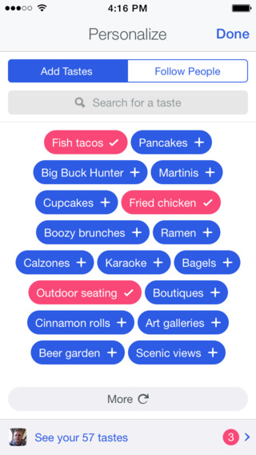

Each user in the system should receive a notification when something meaningful happened in the social network. For example users should receive notifications for unread inbox messages, friend request notifications and received tips from following brands

## 7- Lists

This is one of the most important components in the system. When user opens the application, a list of places should appear to user. This list should be sorted according to one of many strategies, for example this list may sorted according to nearby places, places suggested by my friends (the most places checked in by my friends), the best nearby places (based on place evaluation), user's tastes, … etc. The system should be dynamic and accepts many future strategies for sorting places in the list

Also user should be able to search for a places, and the result of this search should be a list of places, these places should be sorted also according to one of the previously mentioned strategies, or by totally new strategy developed in the future

So there are 2 main lists in the system, the home page list which will appear when user opens the app. And the search places list which will appear when user search for a place

## Resources

<https://en.wikipedia.org/wiki/Foursquare>

<http://time.com/3024078/foursquare-swarm/>

<https://www.swarmapp.com/>

<https://foursquare.com/>

<https://play.google.com/store/apps/details?id=com.friends.aroundme>

<https://play.google.com/store/apps/details?id=com.fsp.android.friendlocator>